
College of Information and Computing Sciences
Student Registration System
Software Requirement Specification

Information Technology Project 2025

Submitted by:

AR-JAY ROS
JAN CARL NEMENZO

Submitted to:

ALBERT CANLAS

Date of submission
AUG 14 2025

1. Introduction

1.1 Purpose
This document defines the functional and non-functional requirements for the Student Registration System (SRS)...

1.2 Document Conventions
All requirements labeled as "REQ-" are mandatory. Use case names follow the format UC-Name. Diagrams follow UML 2.0 conventions.

1.3 Intended Audience and Reading Suggestions
Developers: Focus on Sections 3, 4, and 5...
Testers: Review functional requirements and use cases in Section 4...
Project Managers: Pay attention to constraints, assumptions, and dependencies.

1.4 Product Scope
The SRS automates the student enrollment process, providing secure online registration, course search and selection, payment integration, academic progress tracking, and administrative course management.

1.5 References
IEEE Std 830-1998: Recommended Practice for Software Requirements Specifications
University Academic Regulations Handbook 2025

2. Overall Description

2.1 Product Perspective
The SRS will be a web-based platform integrated with the university’s existing database...

2.2 Product Functions
1. Student Registration
2. Course Management
3. Payment Processing
4. Record Keeping

4.1 E-R Diagram
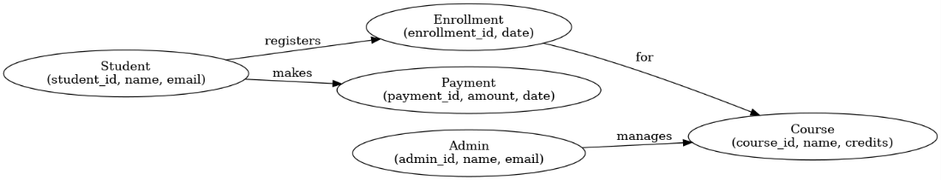

4.2 Use Case Diagram
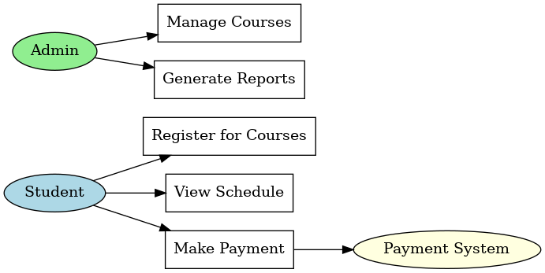

4.5 Activity Diagrams
Activity Diagram - Register for Courses
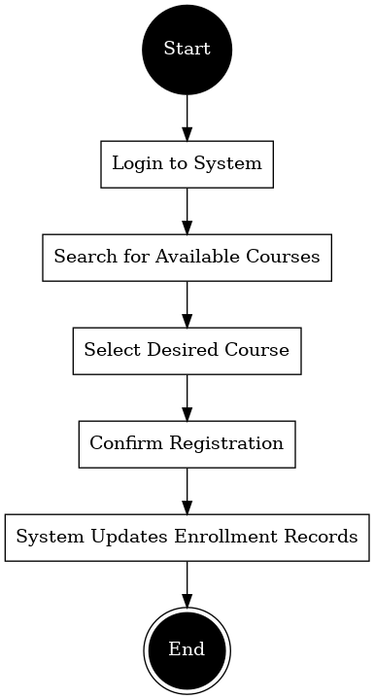
Activity Diagram - Make Payment


